How does the Subsolar Point Change Throughout the Year? Name: _________________________________
At any given moment, the Sun is directly above a specific point on Earth called the subsolar point. The subsolar point is constantly moving since the Earth is spinning.
Throughout the day, the subsolar point moves from east to west since the Earth is spinning from west to east. It also moves north and south throughout the year since the Earth’s axis is tilted at an angle of 23.4° to the plane of its orbit.
In this activity you will use the timeanddate website to find the subsolar times at different times of the year.
Step 1: Go directly to https://www.timeanddate.com/worldclock/sunearth.html or go to https://www.timeanddate.com/, hover over the Sun, Moon & Space tab, and then click Day and Night Map.
It will look something like this.
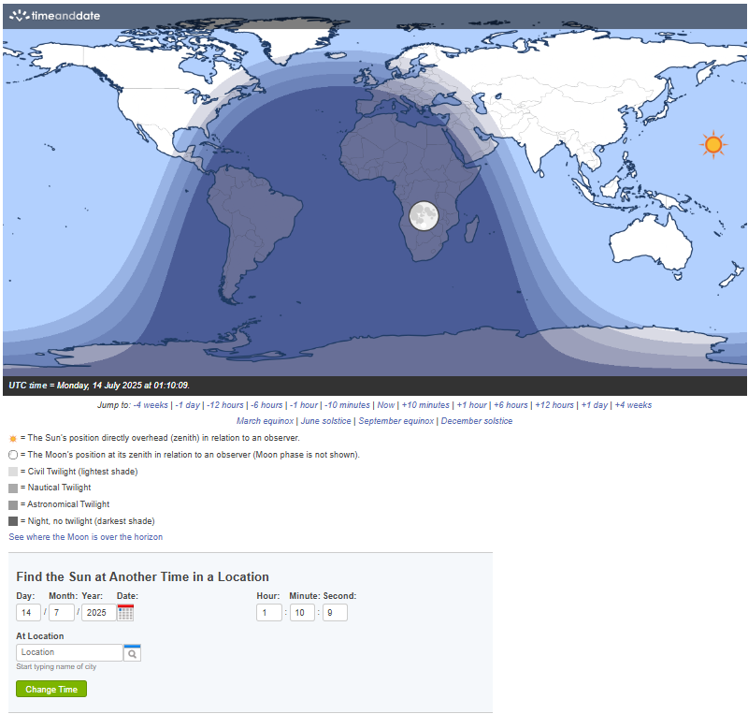
Step 2: In the Find the Sun at Another Time in a Location box, type in your city or town, find the the subsolar point (to the nearest degree) at the dates and times shown on Page 3, and fill in the table. (You have to click Change Time each time).

For example, when I changed…
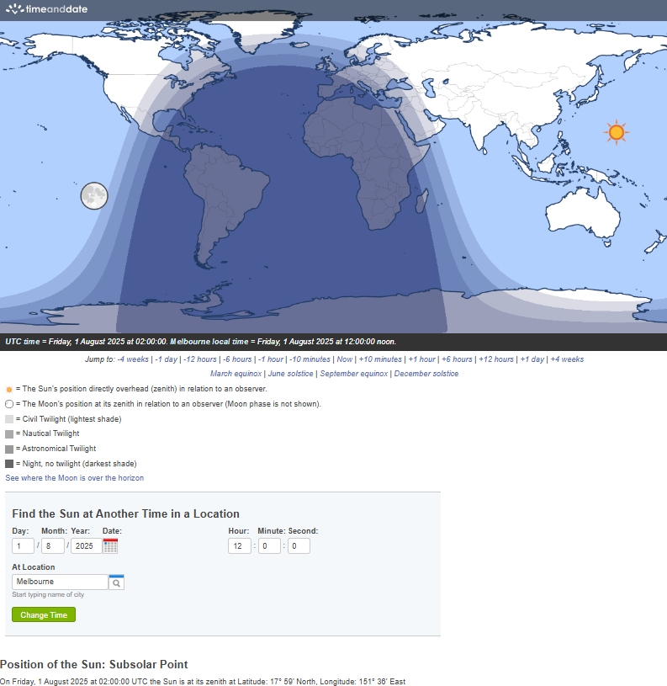
the date to 1/08/2025,
the time to 12:00:00, and
the At Location to Melbourne,
it looked like this.
Note that the map now gives UTC time (which stands for Universal Co-ordinated Time and which is the international standard time) AND Melbourne time.
It also states the latitude and the longitude of the subsolar point (but it writes UTC time, not your local time).
(See the two ovals.) The sun is at its Zenith when it is directly overhead. The word zenith applies to any star or planet; it is at zenith if it is directly above your location.
Step 3: Mark the position of the subsolar point on the map and label it.

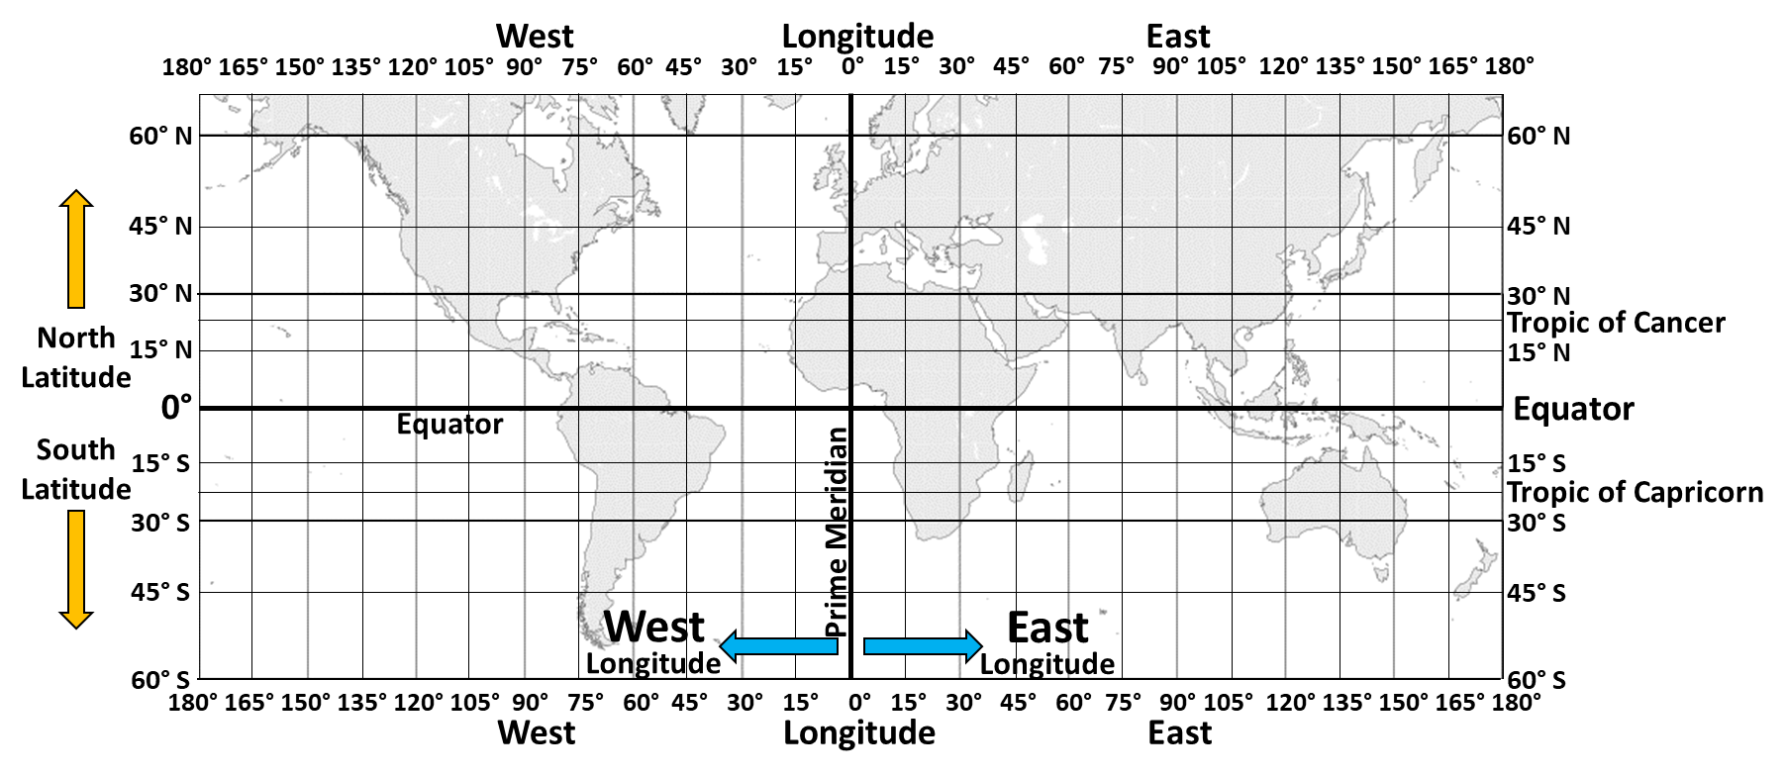
Question 1. What happens to the subsolar point on any given day? ________________________________________________________________________________________________________________________________________________________________________________________________________________________________________________________________________________
Question 2: What happens to the subsolar point throughout the year?
________________________________________________________________________________________________________________________________________________________________________________________________________________________
Subsolar Point on…
Date | Time  (in your location) | Latitude  (don’t forget to write N or S) | Longitude  (don’t forget to write E or W) | Label (for map)
March 21 | 12 pm (midday) |  |  | A
March 21 | 2 pm |  |  | B
March 21 | 4 pm |  |  | C
March 21 | 6 pm |  |  | D
April 21 | 12 pm (midday) |  |  | E
June 21 | 12 pm (midday) |  |  | F
September 23 | 12 pm (midday) |  |  | G
October 22 | 12 pm (midday) |  |  | H
December 21 | 12 pm (midday) |  |  | J

